**Manual for using ADS system**

Start **Advanced Design system 2016.01** from Windows

Click on Help->Create and simulate a circuit: Try it!

The picture gives an overview of the steps that need to be taken in order to perform simulation of high frequency circuits:

1. create a workspace;
2. create a design;
3. simulate a design and
4. view results.

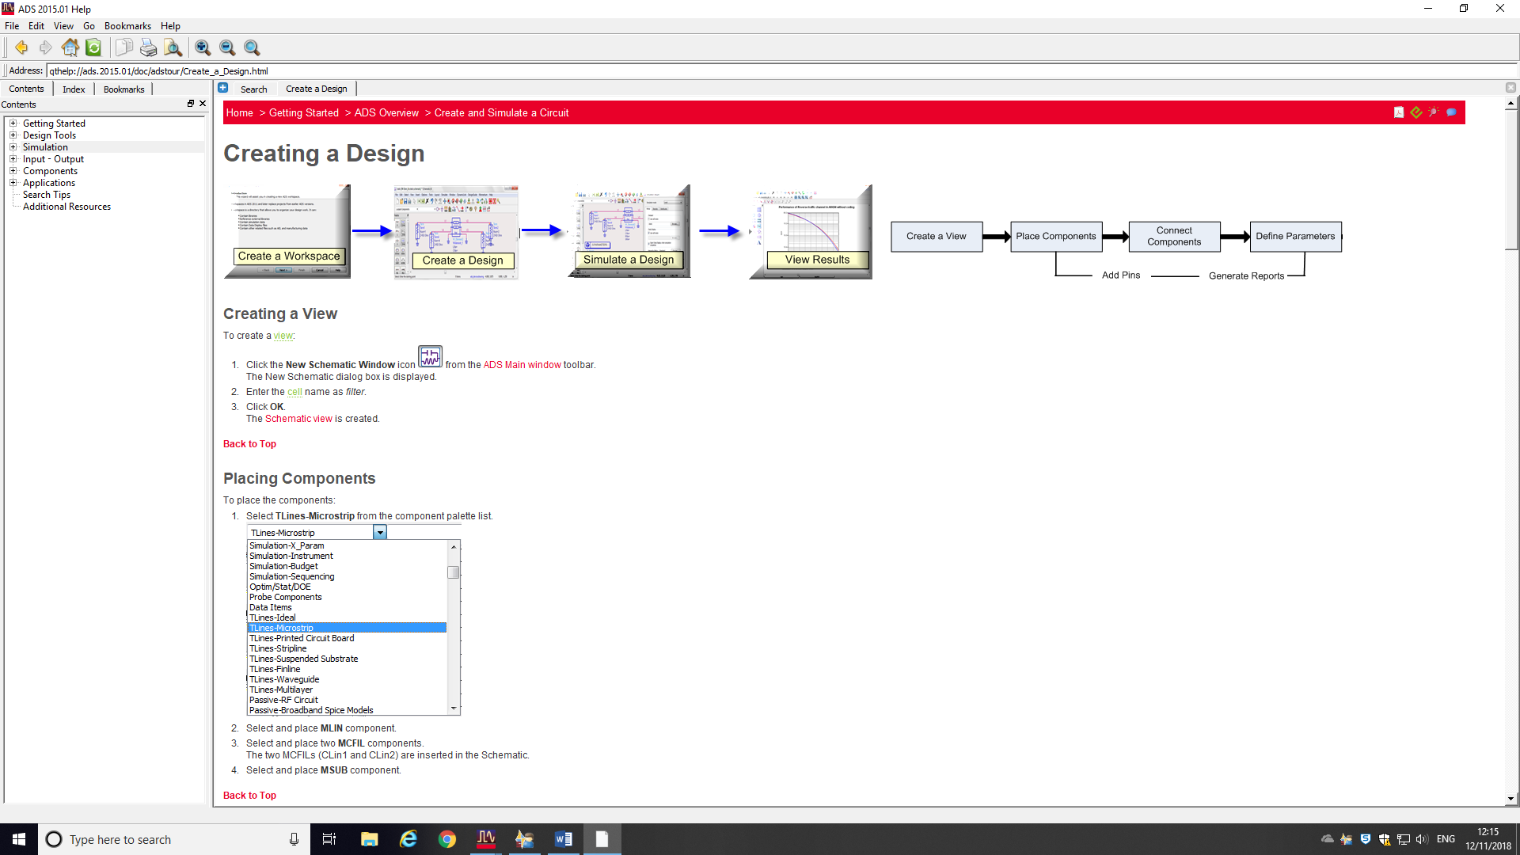

You can click on each box to get more explanations, Below is step by step guide on how to set up a circuit, simulate it and view results.

Close the window “Getting Started with ADS”.

**CREATING A WORKSPACE**

To create a workspace, perform the following steps:

1. Select **File > New > Workspace** from the ADS Main window.  
   The **New Workspace Wizard** is displayed.
2. Click **Next**.
3. Enter the workspace name as *lowpassfilter_wrk*. *(this is the name you want to call your workspace)*
4. Enter the workspace location or click **Browse***. (save this on C:\Users\eey…)*
5. Click Next

Add Libraries:

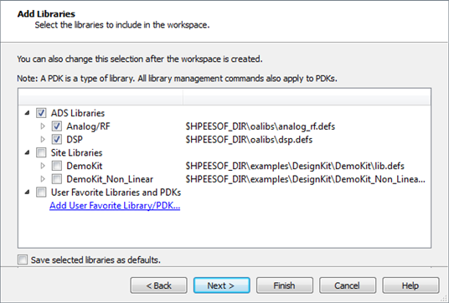

1. Click **Next**.  
   The Library Name page is displayed with the default library name as *bandpassfilter_lib*.
2. Click **Next**.   
   The Technology page is displayed with the default technology as *Standard ADS Layers, 0.0001 mil layout resolution*.
3. Click **Next**.  
   The Summary window is displayed.
4. Click **Finish**.

The lowpassfilter_wrk is created.

**CREATING A DESIGN**

In your coursework you will have to design an **LC filter, transmission line filter and a microstrip filter – IN TOTAL 3 DIFFERENT CIRCUITS**. For each design you need to create a schematic circuit.

To create a circuit you first need to create a separate view:

**Creating a View**

To create a view:

1. Click the **New Schematic Window** icon  from the ADS Main window toolbar.  
   The New Schematic dialog box is displayed.
2. Enter the cell name as *LC_filter*.
3. Click **OK**.  
   The Schematic view is created.

**Placing Components (example for the 3rd order prototype filter). Please note that the value of all components is arbitrary and not representative of a realistic filter).**

To place components (LC filter):

1. Select **Lumped-Components** from the left hand side Palette
2. Select  L and C from the Palette left hand list and add them to schematic.

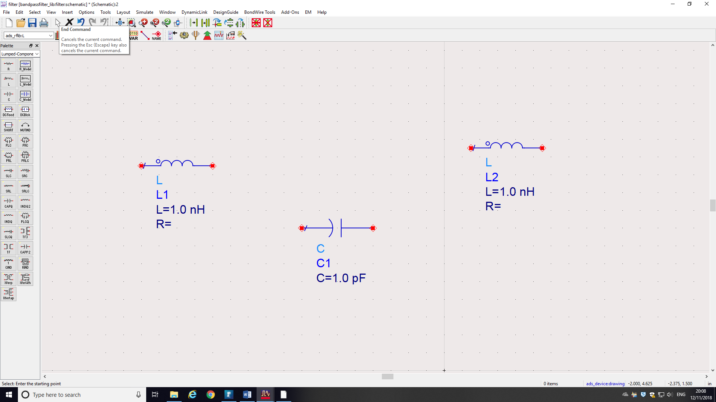

1. Rotate C and R by 90 degrees by clicking on a green circle

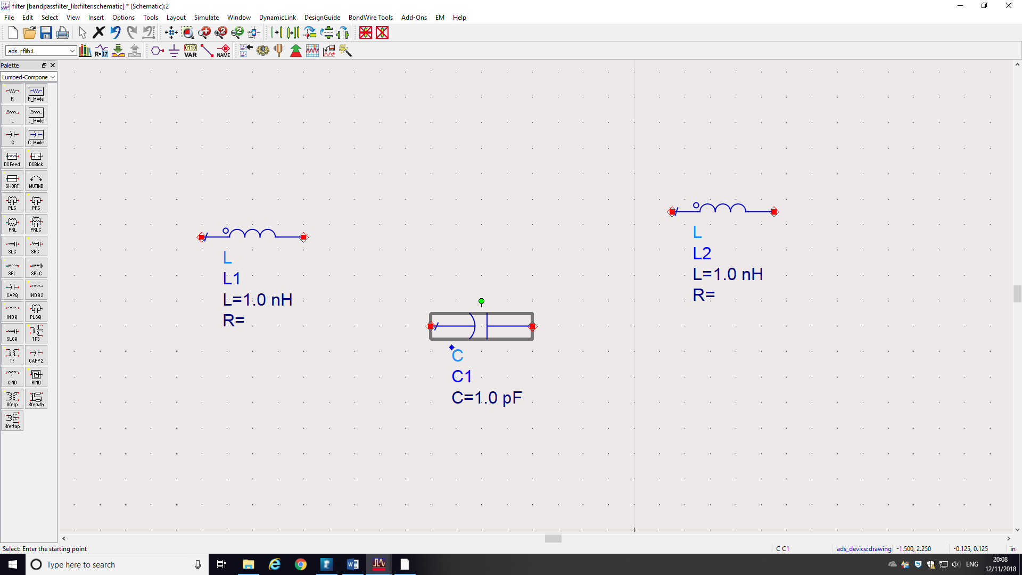

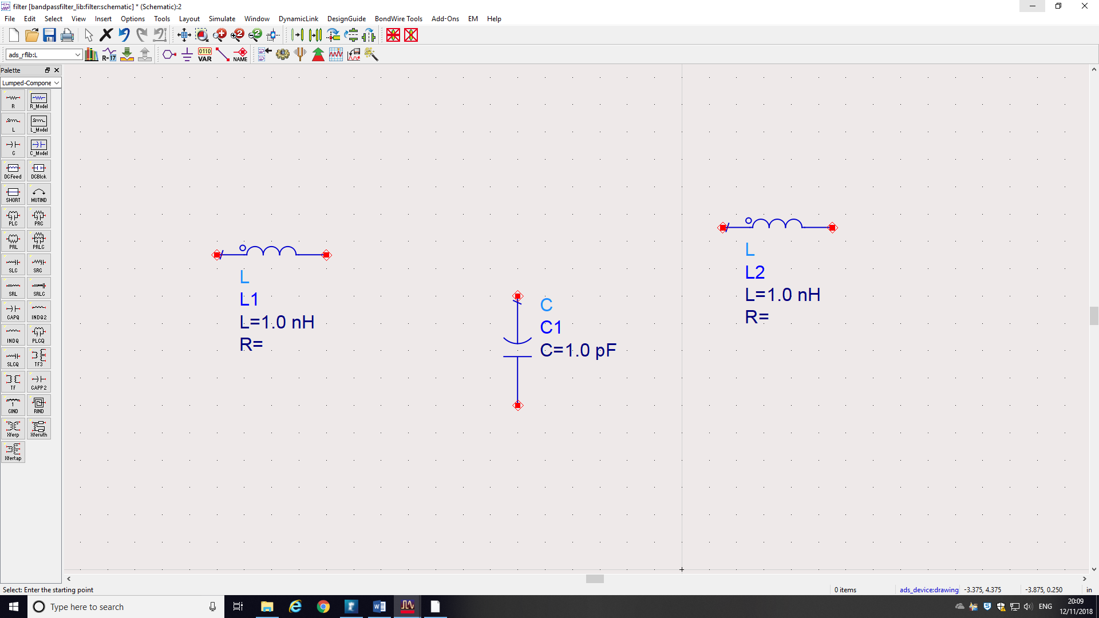

1. Connect components using wire icon  from the toolbar.

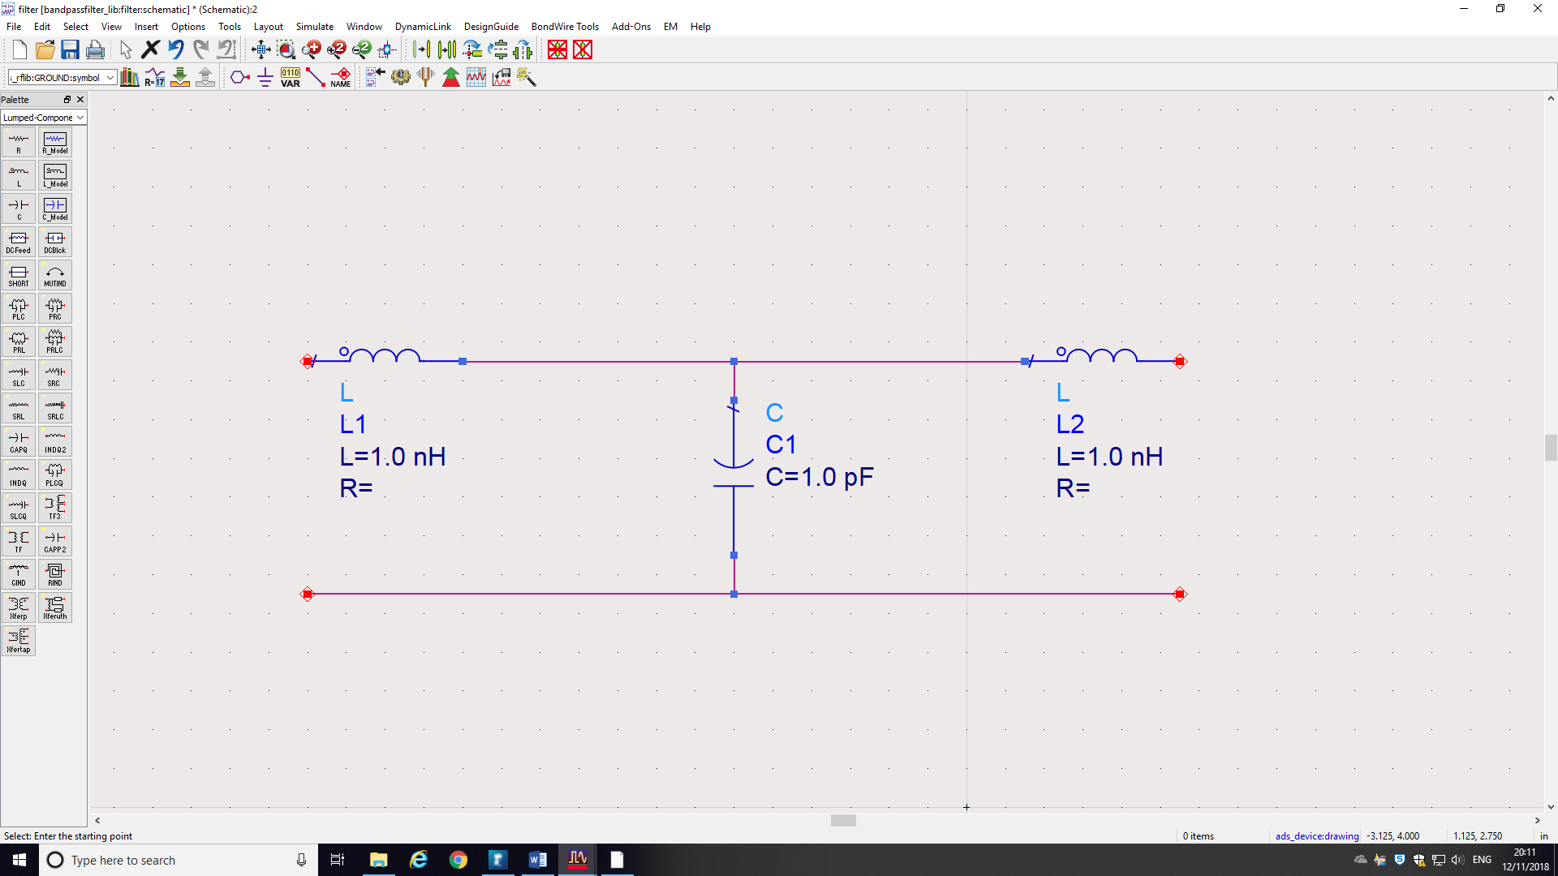

1. Define parameters of L and C in the boxes.

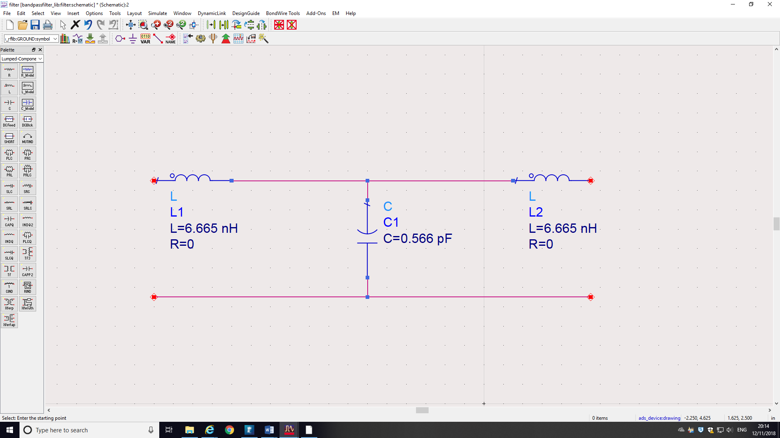

1. Define 2 ports (input and output) by clicking at the port symbol from the toolbar.

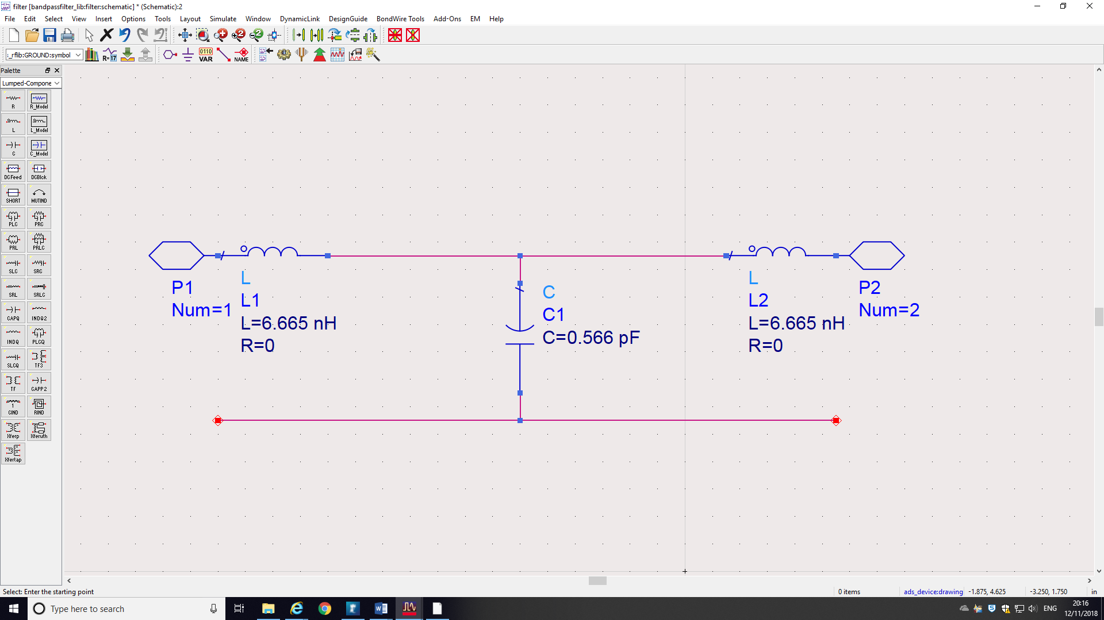

1. Define the ground plane by selecting a ground symbol from the toolbar.

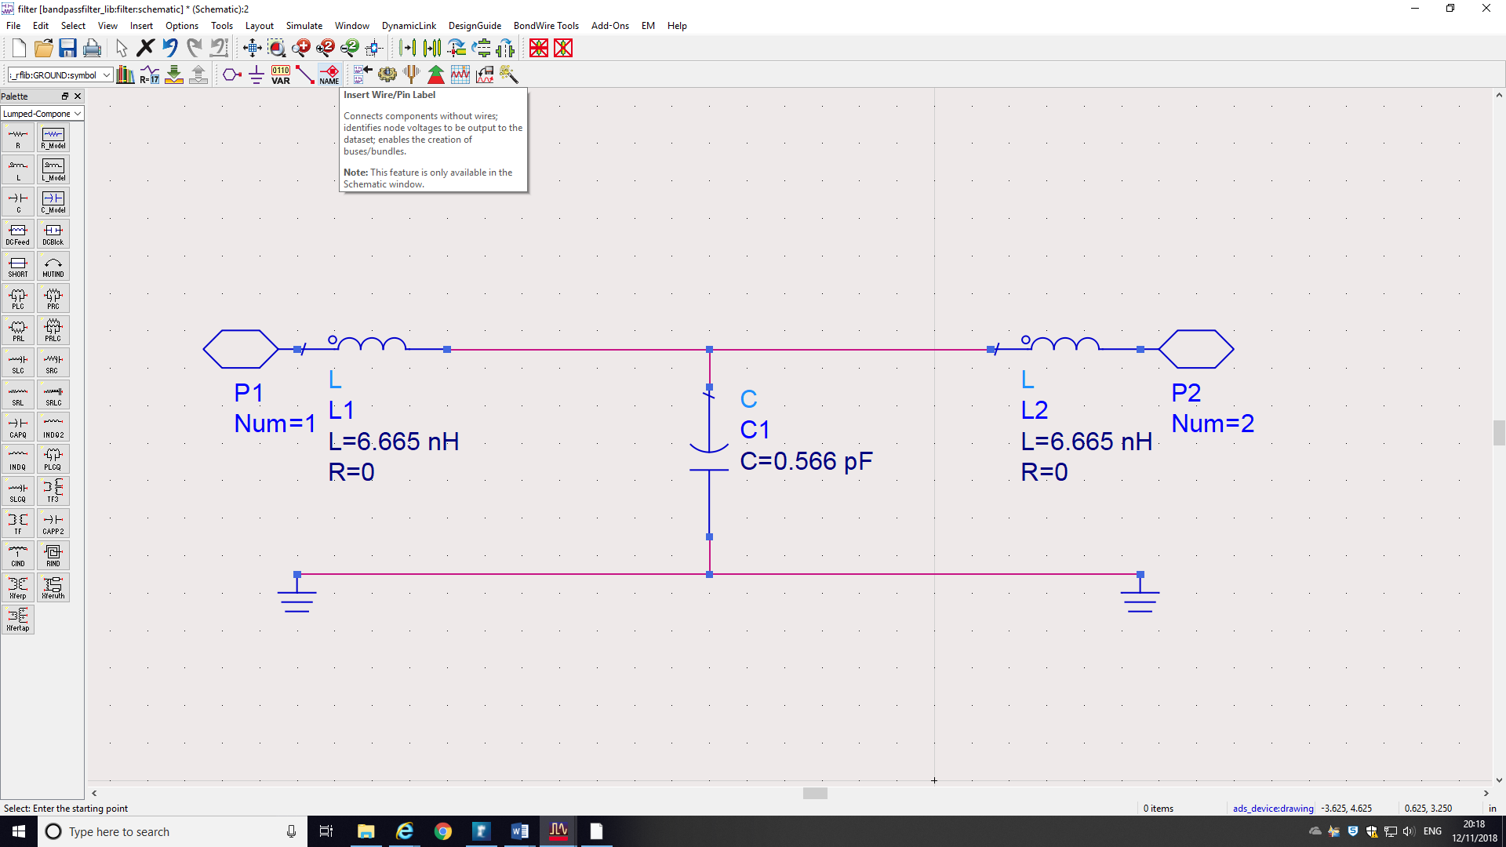

The circuit is now ready for simulations .

**Simulating for S- parameters**

To select a controller:

1. Select **Simulation-S_Param** from the component palette list.  
    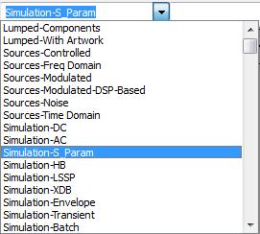
2. Define termination for both ports –by inserting “Term“ from the left hand side Palette. Typically this is a 50 Ohm line:

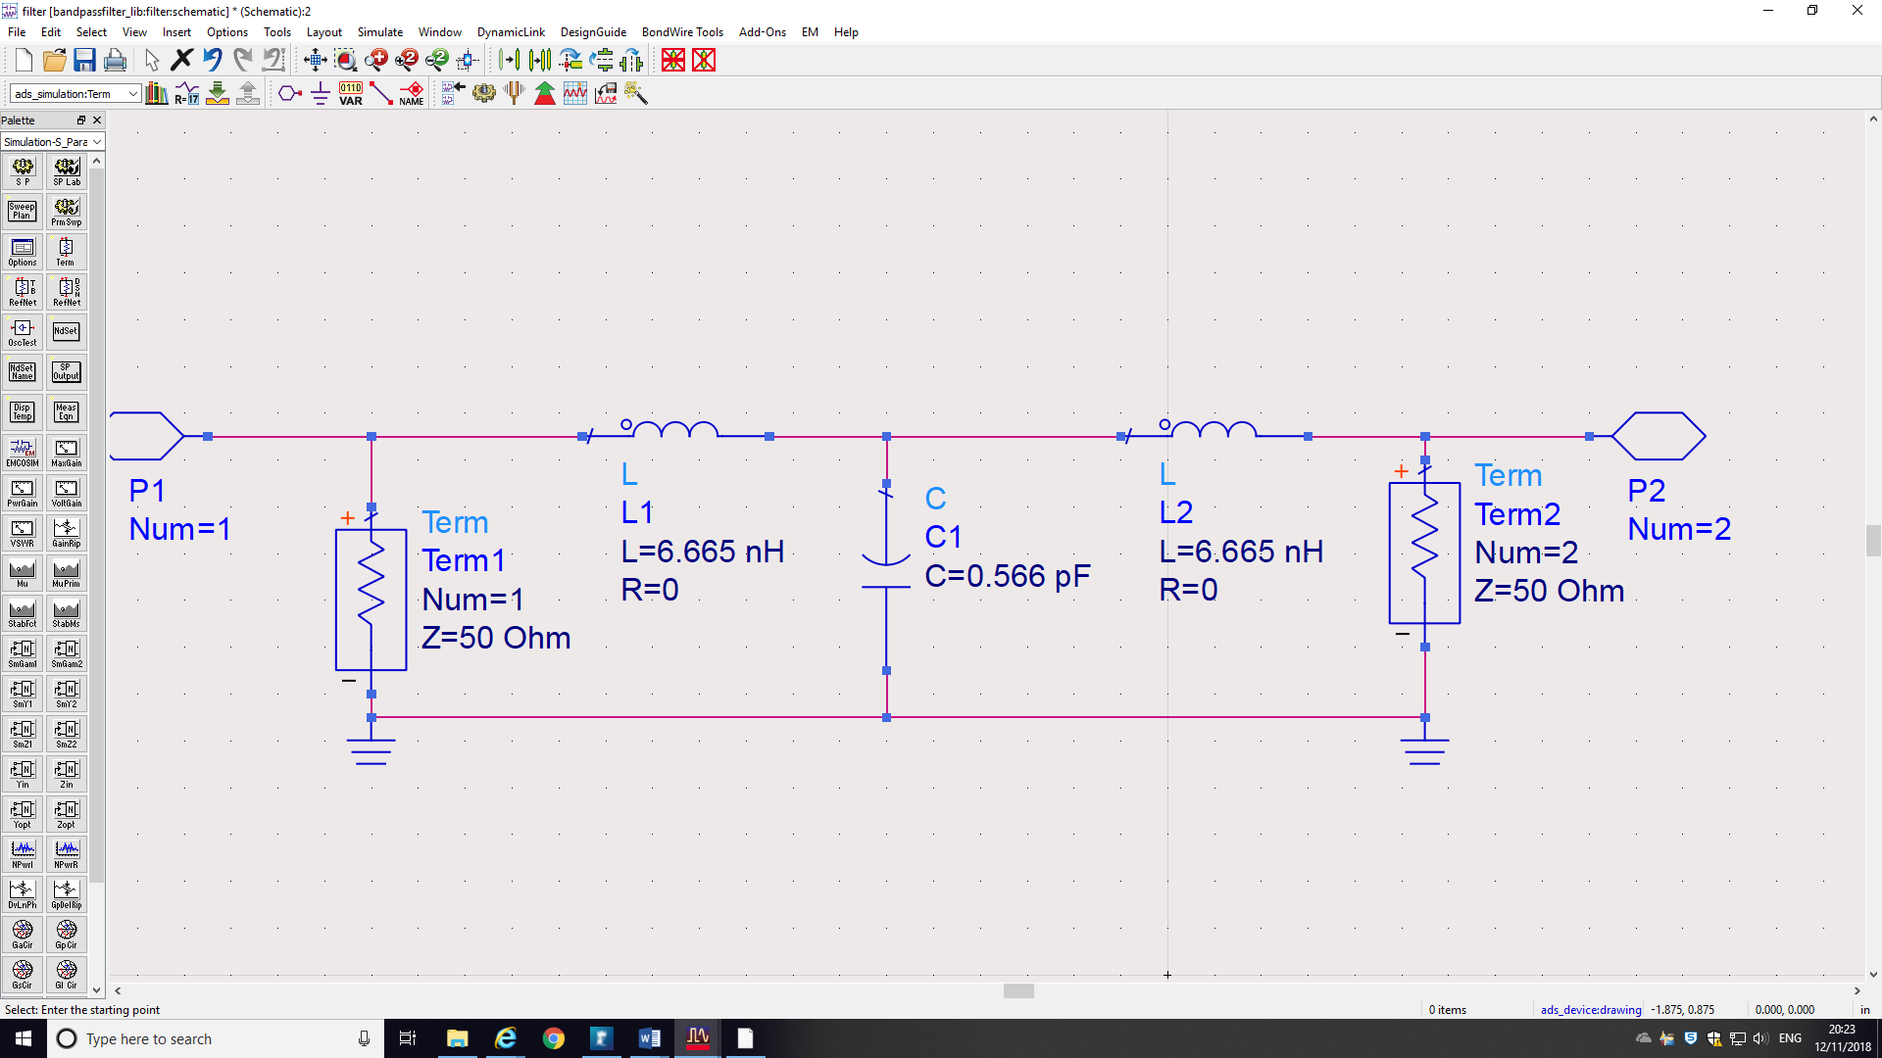

1. Define frequency range – start and stop freq and frequency step by inserting SP from the Palette:

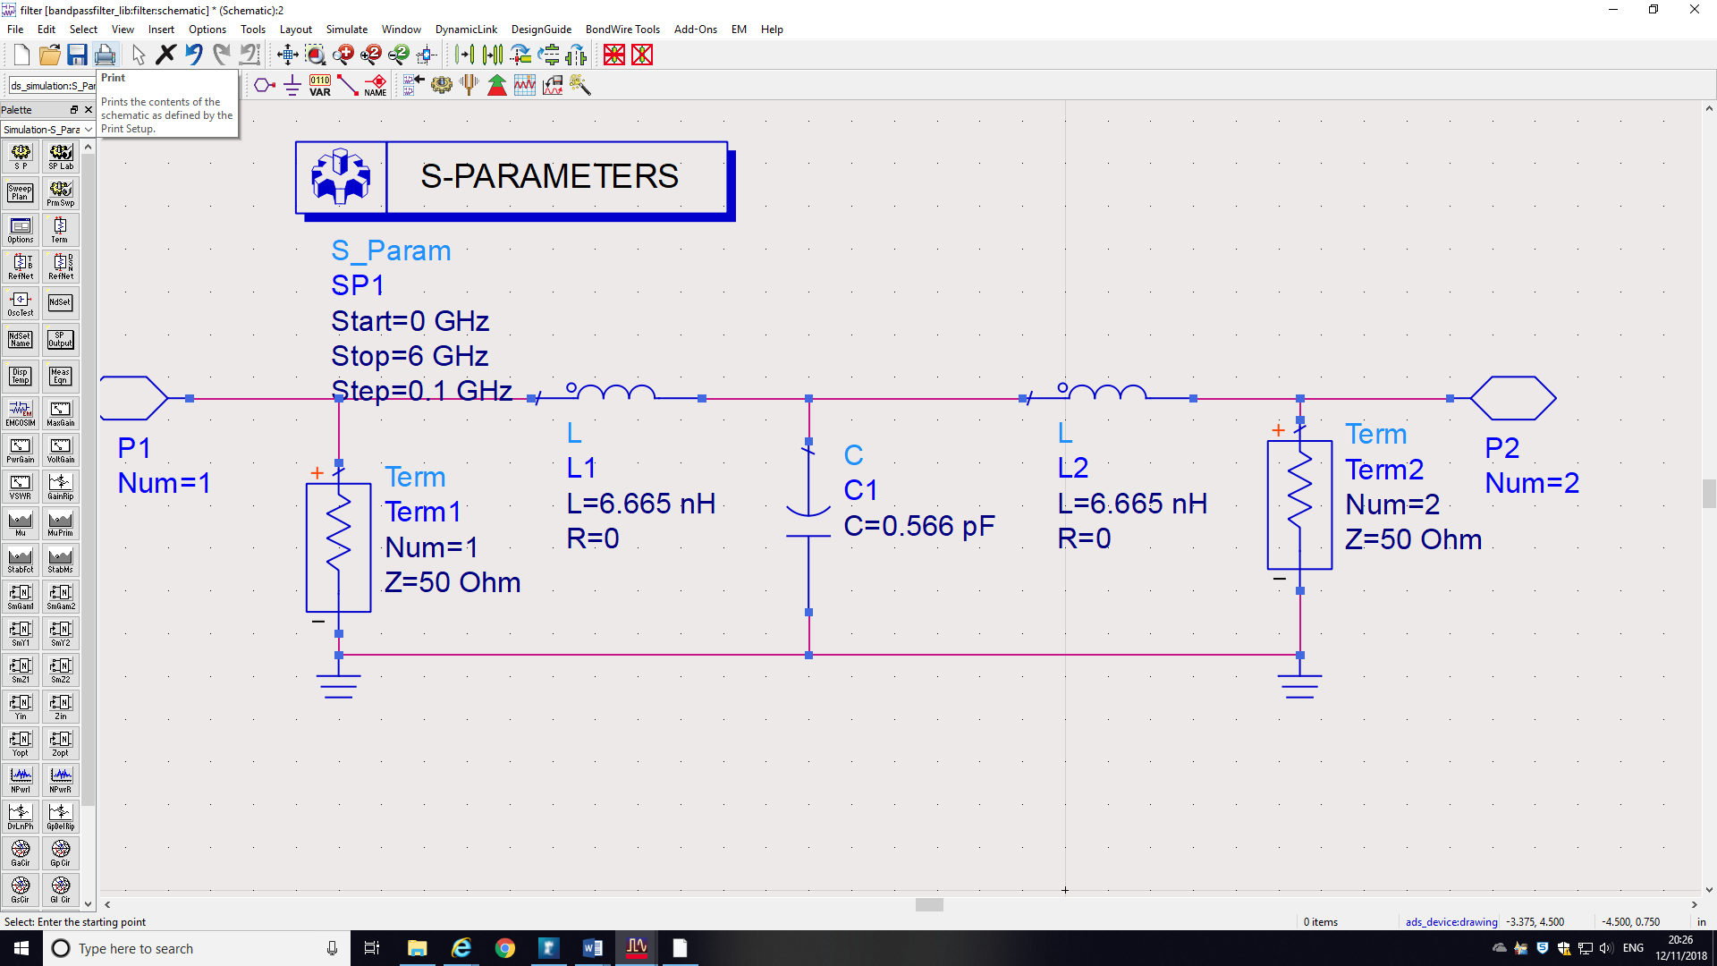

1. To simulate the design click on  icon from the toolbar. A new window will appear.

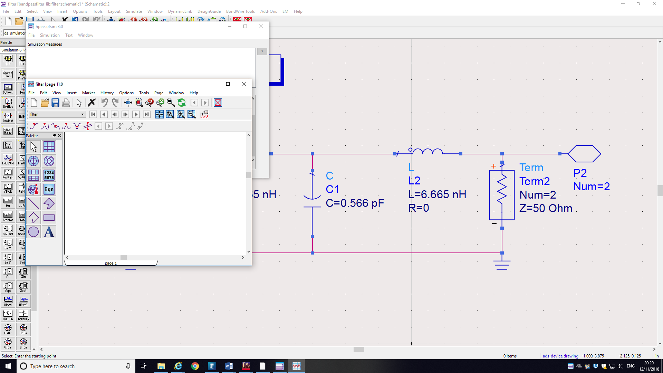

1. Select and place **Rectangular Plot**  from the palette in the new window.  
   The Plot Traces & Attributes window is displayed.  
   * Select **S(2,1)**.
   * Click **>>Add Vs.>>**.  
     The Complex Data window is displayed.
   * Ensure **db** is selected.
   * Click **OK**.  
     The Select Independent Variable window is displayed.
   * Select **freq**.
   * Click **OK**.
   * Select **S(1,1)** and repeat Step 3 to Step 7.
   * Click **OK**.

S21 and S11 parameters are now displayed.

You can add markers by:

* Select the trace.
* Click the **Insert a New Marker** icon .
* Place the Marker on the trace.  
  The marker value is displayed.

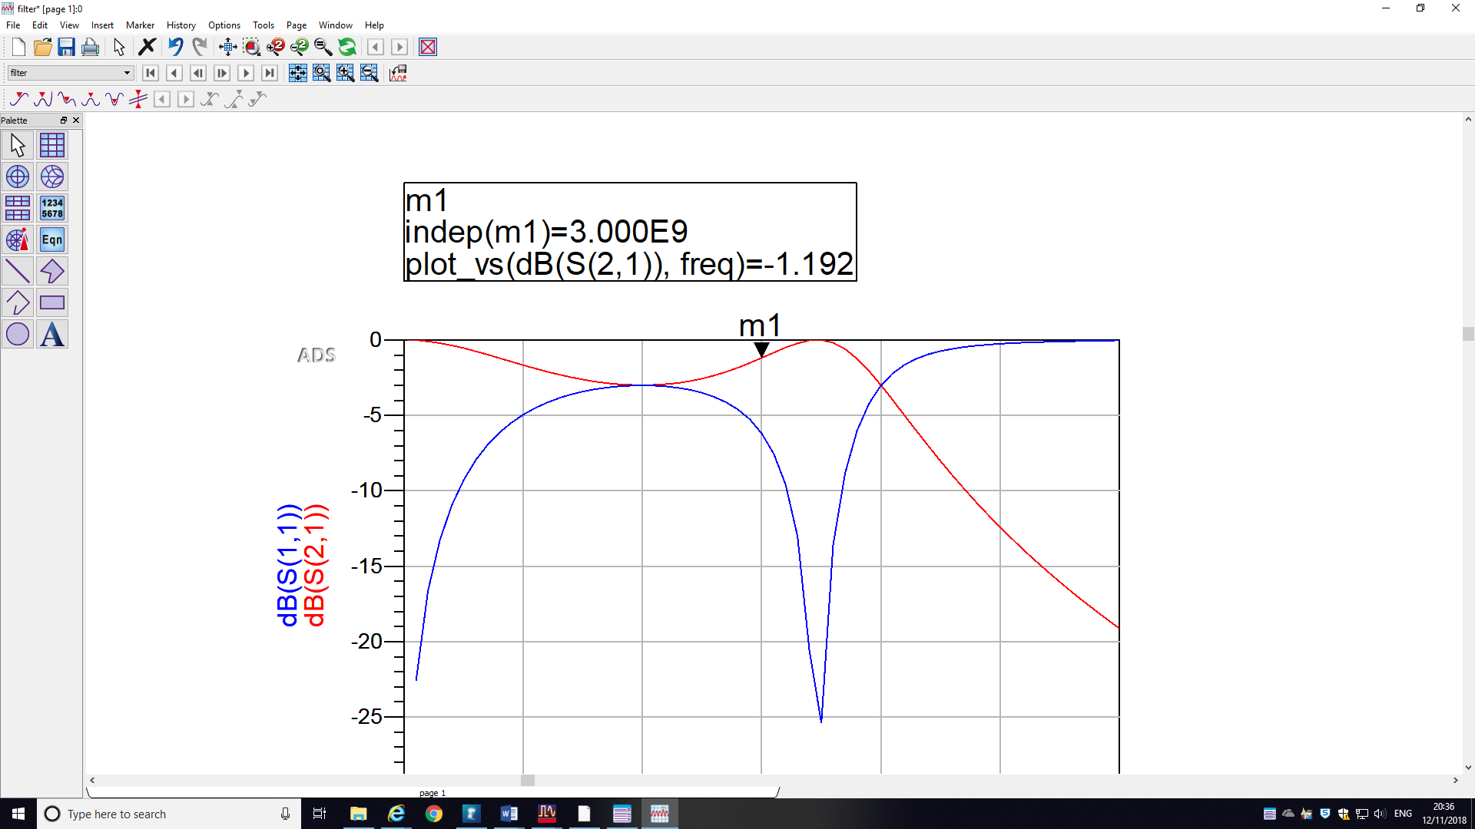

**SIMULATING THE FILTER WITH IDEAL TRANSMISSION LINES**

In the same workspace create a new design:

Name it TL_filter.

In the Palette choose “TLines_Ideal”.

Add 3 TLIN to create a transmission line filter. TLIN defines transmission line. For each transmission line you need to define characteristic impedance Z, electrical length E (E) and operating frequency F.

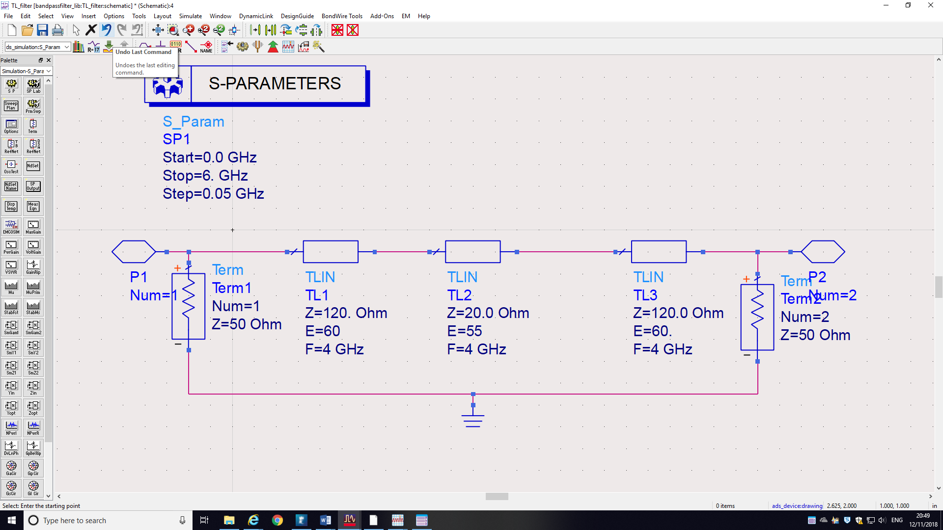

Create the circuit and simulate (define ports and terminations, S-parameters frequency sweep). As before obtain S11 and S21 parameters.

**SIMULATING THE FILTER WITH MICROSTRIP LINES**

In the same workspace create a new design:

Name it microstrip_filter.

In the Palette choose “TLines-Microstrip”.

MLIN symbol represents microstrip line and is defined by width W and physical length L of line in mm.

First convert the TLIN parameters from the TL_filter into microstrip lines. For this use LineCalc tool. Open LineCalc from the windows – under ADS Tools. Define all parameters for microstrip substrate as given in the coursework (use mm units not mil).

Two parameters of transmission lines need to be also inserted Zoin  and electrical length in Deg. Also state the operating frequency (this is cut-off frequency) that you have specified your lines for. Click on **Synthesize** to get widths W and lengths L of the lines in mm. Do that for each individual microstrip line and write down the width and length. Repeat for each TLIN.

Once you have done that insert the appropriate microstrip lines (you will only need MLIN (microstrip line ).

Click on MSUB (microstrip substrate) from the Palette and add to the schematic. Define all parameters of the substrate as given in the coursework.

Create the circuit and simulate (define ports and terminations, S-parameters frequency sweep).

**PRODUCING A LAYOUT**

Click on Layout->Generate/Update the Layout

